**DARK MARKET LAYOUT**

Dark Market Booths (appr 30)

Activities

**Girll**

**Ducks / Goats**

**Haunt Woods Barn**

**Corn**

**tTent**

Food Venues

Hay Wagon / Cow Train Route

Fencing / Visual Block?

Vendor load/unload areas

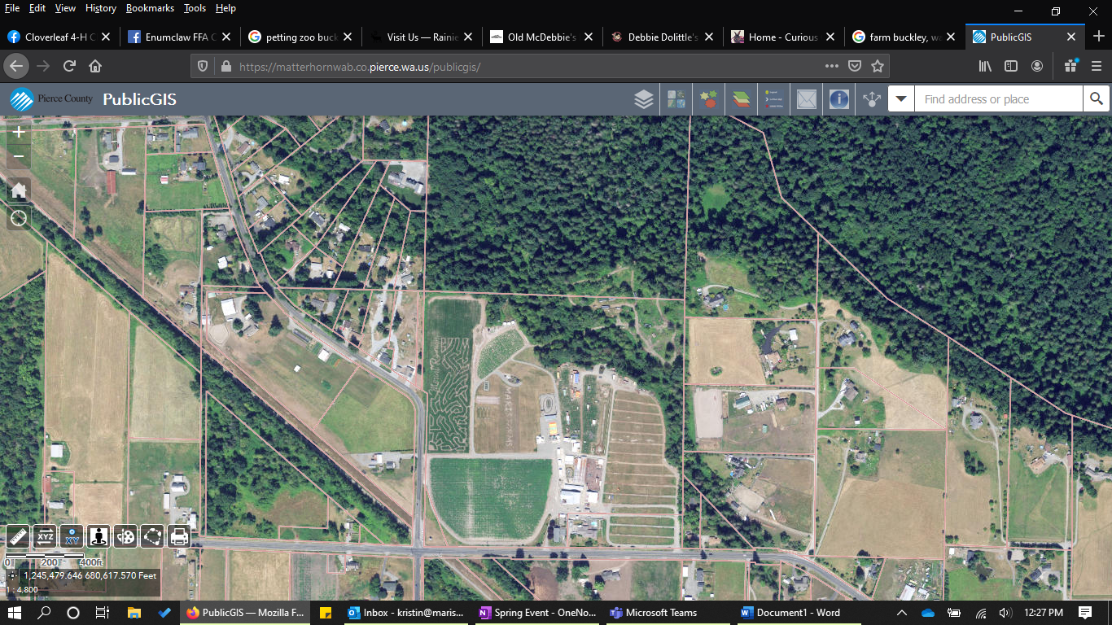

**Flower Cart**

**Cashier / Gifts**

**Field**

**Pumpkins**

**Zip Lines**

**Outside**

**Animal Pens**

**Gaga Ball**

**Ropes Course**

**Giant Slide**

**Kids**

**BARn**

**Courtyard**

**Corn Maze**

**Corn Rm Animals**

**Milk**